Revised Blog Post :
I chose to revise my first blog post. Here is a link “Topic #1 response” I believe I have learned a lot throughout the course and I feel I am able to re-examine what I wrote in the beginning of this course after having discussed in great detail the information and concepts we have looked at since the beginning of July.

After having completed the learning outlined in the EDCI-339 course, I have come to the decision that for me, personally and for my teaching practice, a “blended” learning environment is the model I will adopt in the future. Having done some additional research, I have found the following definition of blended learning, “Blended learning is an educational program that combines online digital media with traditional classroom teaching methods. Therefore, blended learning is a broader, more comprehensive approach that includes eLearning and might also incorporate elements of micro-learning. (https://www.pdagroup.net/) Furthermore, Vaughan et al. 2013) describe blended learning as an organic selection of carefully and thoughtfully selected in person and online resources. In addition, Norberg et al. (2011) go on to state that, “Blended and online learning generates considerable optimism because it increases access for students to education, responding to their lifestyles through flexible learning opportunities.” The statement that online learning created optimism with learners as they can access it on their own time resonated with me. We are faced with a new normal where online learning must become part of an educator’s pedagogical considerations
However, Norberg t al. (2011) do bring up a good point when they bring up the point that “blended learning” can be perceived as a problematic term. Which teaching methods are blended and in what proportion are they blended? I don’t think the proportion of blended teaching methods matters as much as the blend itself. In fact, Major, (2015) states that good pedagogy should always be at the forefront when designing a course. My belief is that as long as the teacher has the best interests of their students in mind when developing their curriculum, a blended learning environments provides them with a larger resource base.
While I understand the importance and specific advantages to both the open and distributed learning models, for me personally, as an educator neither of those platforms lends itself well to the students in my classroom. They both have pros and cons attached to their very description. For instance, distributed learning offers a safe, restricted access, closed door program that enables students to interact with their instructor as well as with the other members of their group. One draw back of this

system is that the students do not have the ability to share their learning outside of the group. Conversely, an open learning platform allows the information to be shared with anyone who wishes to view it and has access to it. While the flexibility of accessing the information therein is admirable, there is a question around the safety and the security of those choosing to participate in such a learning environment.
All that said, I found a very interesting visual that sums up the make-up of a pedagogically sound blended learning environment. The article on the PDA Group outlines the 7 most important methods of delivering instruction and how the students responded positively to their experience in the blended learning classroom.
, 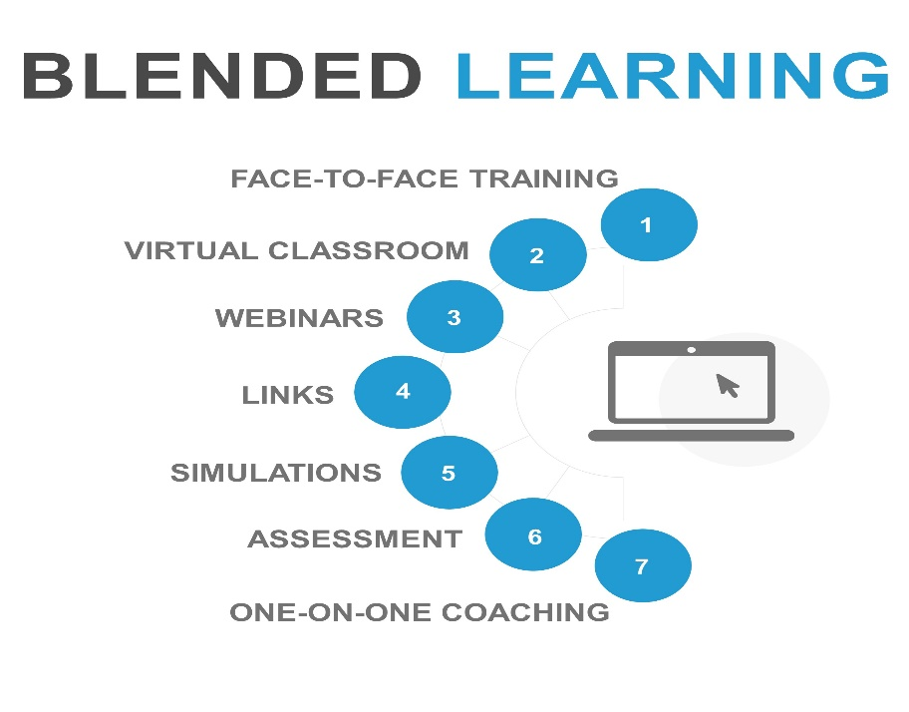
In conclusion, I have enjoyed learning more about the open and distributed learning environments and all they have to offer. I understand that in the right educational context, either would be a great option for both teaching and learning however, for my purposes, and in my educational context, I believe the blended learning model best suits my needs.

References :
- Claire Howell Major. (2015). Teaching Online - A Guide to Theory, Research, and Practice. Retrieved from
http://ebookcentral.proquest.com/lib/uvic/detail.action?docID=3318874 (pp. 88-105)
- Morris, S. M., & Stommel, J. (2018). An urgency of teachers: The work of critical digital pedagogy. Hybrid Pedagogy.
- Norberg, A., Dziuban, C.D. and Moskal, P.D. (2011), "A time‐based blended learning model", On the Horizon, Vol. 19 No. 3, pp. 207-216.
- Vaughan, N. D., Garrison, D. R., & Cleveland-Innes, M. (2013). Teaching in blended learning environments: Creating and sustaining communities of inquiry. AU Press. [Chapter 1]
- https://www.pdagroup.net/en/spotlight/7-ways-blended-learning-will-inspire-you

